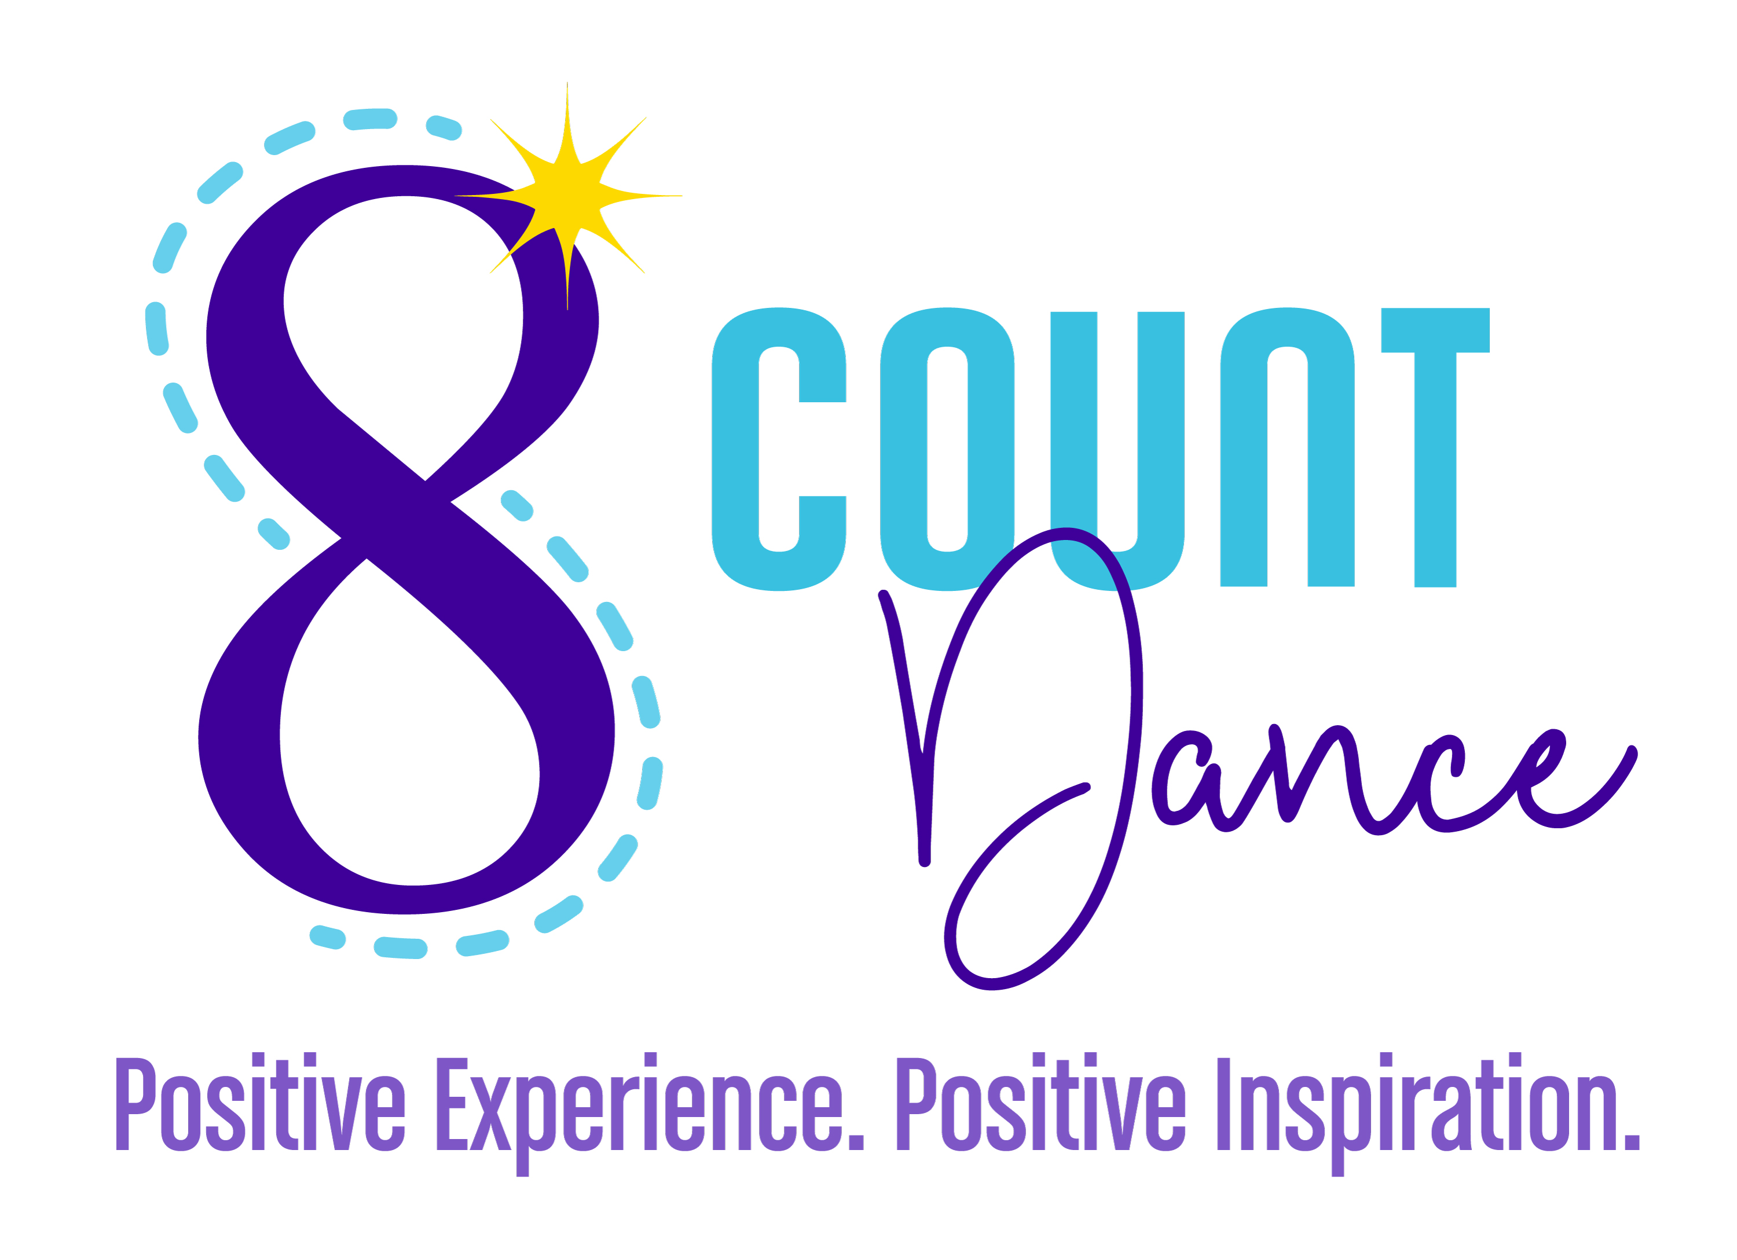
GOOD LUCK MESSAGE
Wouldn’t your dancer LOVE to read a
“GOOD LUCK” message in the Recital Program?
Your dancer will feel so special!

DUE APRIL 22, 2023- Each ad is $5 per 15 words.

*Advertise your business with a Business Card Ad for $30
Please attach your business card and return with this form.

Forms of payment:
Venmo (@Andrea-Polyak) or CASH:

Student Name:

Student Name:

GOOD LUCK MESSAGE
Wouldn’t your dancer LOVE to read a
“GOOD LUCK” message in the Recital Program?
Your dancer will feel so special!

DUE APRIL 22, 2023 - Each ad is $5 per 15 words.

*Advertise your business with a Business Card Ad for $30
Please attach your business card and return with this form.

Forms of payment:
Venmo (@Andrea-Polyak) or CASH:

Student Name:

Student Name:

